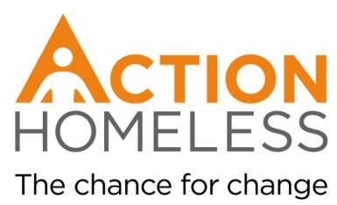
Pop-Up Shop Set Up Volunteer
Purpose of the Role:
Help set up our Christmas Pop-Up Shop. Sort through donations and present them in a way that will ensure a pleasant and easy shopping experience for our clients.
Main tasks and activities:
- Sorting through donations of clothes into different items and sizes.
- Ensuring that clothes are clean and in a suitable condition to be given to clients
- Create an exciting pop-up shop that will enable a pleasant shopping experience for clients.
Qualities, experience and skills sought:
Whilst previous experience of the role is not essential, we are looking for individuals with the following skills and aptitude, approach and personal qualities:
- Reliable
- Organised
- Enthusiastic
- Creative
- Interest in helping homeless people
- Good communication skills
Training provision – our commitment to you:
We’ll provide you with an introduction to Action Homeless and brief you on the plan for the day.
If you are interested in this role, please fill our and return an application form by Monday 3rd December. You will receive confirmation of your role and volunteering slot that week along with any other relevant information.
We aim to accommodate as many volunteers as possible over Christmas. If for any reason we are unable to accommodate you or the opportunity you apply for is full then you will be placed on a waiting list and notified of any openings.
Availability: Thursday 27th December, minimum of 2 hours between 10am and 4pm
Location: Engage, 6 St James Terrace, Leicester, LE2 1NA
Main point of contact:
James Riviere
jamesriviere@actionhomeless.org.uk
0116 221 1851

