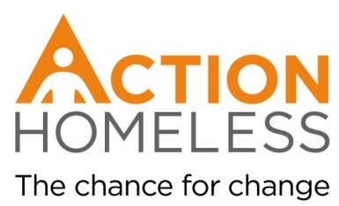
Pamper Day Volunteer
To take part in a pamper day for Action Homeless Clients.
Run personal wellbeing sessions, cut hair, or give Action Homeless client’s beauty or wellbeing treatments.
Qualities, experience and skills sought:
- A qualified therapist and / or hairdresser
- OR someone who enjoys pampering or painting nails
- Reliable
- Enthusiastic
- Interest in improving the wellbeing of homeless people
- Ability to communicate with a wide range of people
- Approachable and friendly
- Organised
Training provision – our commitment to you:
We will provide you with an introduction to Action Homeless and will provide pamper supplies where possible.
If you are interested in this role, please fill our and return an application form by Monday 3rd December. You will receive confirmation of your role and volunteering slot that week along with any other relevant information.
We aim to accommodate as many volunteers as possible over Christmas. If for any reason we are unable to accommodate you or the opportunity you apply for is full then you will be placed on a waiting list and notified of any openings.
Availability: Thursday 27th December, minimum of 2 hours between 10am – 4pm
Location: Engage, 6 St James Terrace, Leicester, LE2 1NA
Main point of contact:
James Riviere
jamesriviere@actionhomeless.org.uk
0116 2211 851

