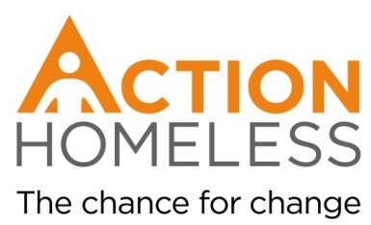
Pamper Day Volunteer
To take part in a pamper day for Action Homeless Clients.
Run personal wellbeing sessions, cut hair, or give Action Homeless client’s beauty or wellbeing treatments.
Qualities, experience and skills sought:
- A qualified therapist and / or hairdresser
- OR someone who enjoys pampering or painting nails
- Reliable
- Enthusiastic
- Interest in improving the wellbeing of homeless people
- Ability to communicate with a wide range of people
- Approachable and friendly
- Organised
Training provision – our commitment to you:
We will provide you with an introduction to Action Homeless and will provide pamper supplies where possible.
Availability: Friday 29th December, any time between 10am – 4pm
Location: Engage, 6 St James Terrace, Leicester, LE2 1NA
Main point of contact:
James Riviere
jamesriviere@actionhomeless.org.uk
0116 2211 851

