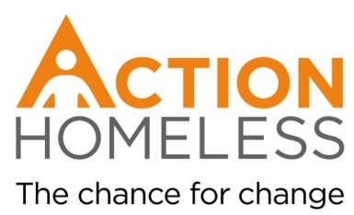
Community Fundraiser Volunteer
Help us raise funds for our 2017 Winter Appeal at our Bag Packing Community Fundraiser.
Main tasks and activities:
- Being an Action Homeless representative within the local community
- Packing customers shopping bags in exchange for donations
- Talking to customers about Action Homeless’ work
Qualities, experience and skills sought:
- Reliable
- Enthusiastic
- Interest in helping homeless people
- Good communication skills
- Approachable and friendly
Process:
If you’re interested in this role, please fill in an application form and return it to us.
Please return your form by Monday 4th December.
Availability: Minimum of 1 hour between 9am and 5pm
Main point of contact:
James Riviere
jamesriviere@actionhomeless.org.uk
0116 2211 851

