

**Community Transitions Supported Housing Officer**

**Application Pack**

**Closing Date: 25th September 2017**

**Contents**

Page

Advertisement 3

About Action Homeless 4

Job Description 6

Person Specification 9

How to Apply 12



**Community Transitions Supported Housing Officer**

**Contract:** Fixed Term

**Hours:** 37 hours per week

**Salary:** £22,322 - £24,512 – scale points 24-27

Action Homeless is a local charity dedicated to tackling the causes and consequences of homeless in Leicester and Leicestershire. We are looking to recruit an enthusiastic individual to offer Transitional Housing support to clients leaving mental health services and hospital settings.

You will be navigating housing waiting and bidding systems, looking for innovative housing solutions and supporting people to resettle sustainably into their new homes. You will oversee rent and void management and provide practical advice and information on a wide range of issues including, housing, welfare rights, finance, and life skills.

We are seeking an individual who has experience of sustaining tenancies and housing management, working with vulnerable client groups and safeguarding practices, strong time management and work prioritisation skills, and the ability to communicate logically, concisely and effectively at all times.

Full details about the role including the person specification can be downloaded from our website [www.actionhomeless.org.uk](http://www.actionhomeless.org.uk) alternatively please call 0116 2211882

To apply please complete and return our application form to

[aaliyahlawrence-browne@actionhomeless.org.uk](mailto:aaliyahlawrence-browne@actionhomeless.org.uk)

**Closing date:** 25th September 2017

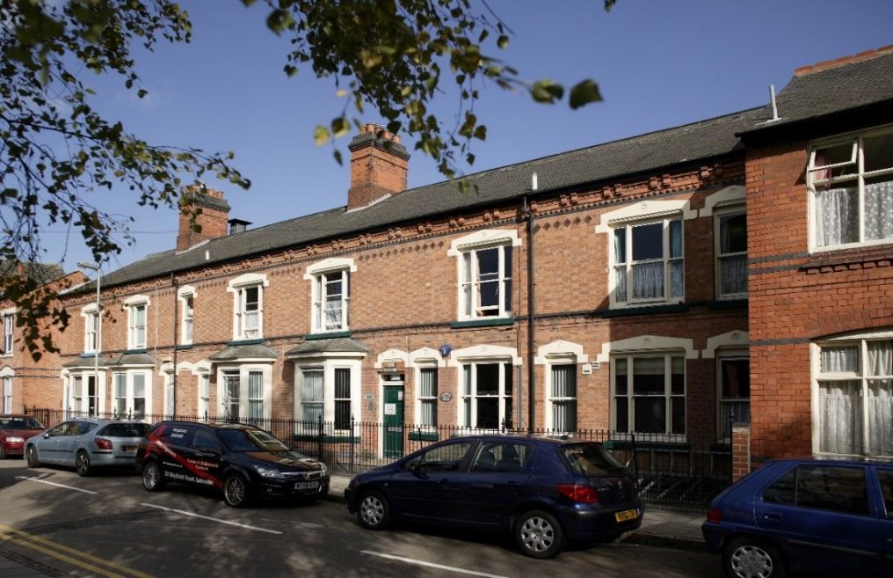**Assessments & interviews:** 5th October 2017

**About Action Homeless**

Action Homeless provides a range of services for homeless people and people who are worried about homelessness in Leicester and Leicestershire. These include information, advice and accommodation services. We also work within the community to try to prevent homelessness from occurring in the first place. Our services aim to give people the confidence and skills they need to achieve and maintain independent living and to make a great contribution to the local community.

We believe that, wherever possible, it is much better to prevent homelessness from occurring before people reach a crisis in their lives. Preventing homelessness is a key focus for Action Homeless and an area, which we will be developing over the next five years. We launched a ‘No Second Night Out’ in Leicester which is a partnership project, that aims to ensure that anyone rough sleeping in Leicester is linked with accommodation and support services as quickly and efficiently as possible.

Unfortunately, there are cases where people do reach crisis point and find that they do not have a safe place to stay. In these situations, we are here to help and work with Leicester City Council to provide emergency accommodation to vulnerable adults who need it. In addition, our Accommodation Assist project offers high quality temporary housing to people who are homeless or threatened with homelessness and need a safe place to live whilst identifying more stable and permanent housing. Our accommodation across Leicester varies to include large supported housing projects, small-shared houses, bedsits and self-contained flats.

Action Homeless successfully brought back into use 20 empty properties through funding secured from DCLG. The project renovated empty properties, transforming them into affordable accommodation for people leaving homelessness services. In line with our strategic priorities, Action Homeless plans to continue with this work and provide an affordable solution to homelessness.

During 2016, we were successful in obtaining £140,000 from Nationwide Foundation, which helped us to purchase and renovate a further 3 properties. This also meant we were able to create 17 more units of affordable housing accommodation.

We believe that putting a roof over someone’s head is only the first step to helping them to regain their independence and therefore we provide access to an extensive support programme, which includes:

Engage – a purpose built support centre which acts as the base for a varied events and activities programme that promotes skills development and independence.

Action Trust – a social enterprise that offers work placements, training and employment opportunities to ex-offenders and people with experience of homelessness.

Moneywise – a project that seeks to improve individual’s financial confidence through a programme of group workshops and one-to-one training and education.

More information about Action Homeless and what we do can be found on our website at [www.actionhomeless.org.uk](http://www.actionhomeless.org.uk)

**Community Transitions Supported Housing Officer Job Description**

**Job Title:** Community Transitions Supported Housing Officer

**Responsible to:** Director of Services/Deputy CEO

**Hours:** 37 hours per week

**Salary:** £22,322-£24,512 – scale points 24-27

1. **Job purpose**

To provide a comprehensive housing support and management, which offers transitional housing services to clients who are ready to leave hospital, awaiting permanent accommodation, and would otherwise be at risk of failing their tenancies. You will promote and encourage independence, quality of life, health and wellbeing.

You will oversee rent and void management and provide practical advice and information on a wide range of issues including, housing, welfare rights, finance, and life skills. You will need to show empathy with, and be aware of the need of people who have suffered from mental health conditions, and may be vulnerable for a variety of different reasons. Clients will be coming from hospital environments and living in the accommodation for short periods of time, they will require support to readjust to life outside of clinical settings, while working towards resettlement in permanent accommodation

1. **Specialist Transitional Support Duties:**

You will have experience of supporting customers with multiple and complex needs from a psychological perspective in a supported housing context, and understand the resettlement processes for clients with a history of homelessness or failed tenancies:

Working with people: Providing 121 psychologically informed support and working with facilitating future housing move on accommodation in accordance with agreed plans.

1. Working with various teams in the community: providing and facilitating case management. Progressing actions plans created with the clients and partners, to achieve a positive and sustainable move into the community for clients coming from hospital.
2. Working with the wider context:
3. Internally: Providing guidance, support and delivery of project outcomes across the pilot project, while using skills and expertise to promote better mental health within the organization.
4. Externally: Close liaison with stakeholders and services, informing and reporting on performance related targets, and supporting the project to meet key activity in the service level agreements with mental health and housing partners.
5. Good understanding of the housing needs of the group and knowledge skills to navigate the local housing options and other services to achieve positive results.
6. The ability to undertake assessments and contribute to effective team working.
7. The respect for others and personal ambition it takes to succeed.
8. **Main duties**
   1. Support the journey taken by prospective new tenants from offer through to sign up. Liaising with referring staff to build a picture of the support needs the tenant may have.
   2. To provide an effective and efficient client focused accommodation allocation service, ensuring high standards of customer care, equal opportunities and fair treatment are met. Holding regular engagement with the Action Homeless support team/premise staff to fully understand tenant’s needs and backgrounds.
   3. To sign up new tenants and to advise them of their rights and obligations under the condition of their tenancies/license agreements and fully induct tenants into their new accommodation.
   4. To ensure benefit applications are complete before move in and payment options are fully explained to the tenant. Carry out regular benefit checks with tenants.
   5. To assist clients with life skills, money management, social skills and health/wellbeing in order to promote their independence and successfully sustain their tenancies/licenses. This will also include liaising with support agencies the tenants may be involved with.
   6. Agree a housing management plan with all new tenants, this should include a schedule of visits and length of programme.
   7. To be the first point of contact in all matters relating to our clients tenancies or licenses e.g. housing benefit advice, arrears advice, anti-social behavior issues including neighborhood disputes, harassment and domestic violence.
   8. To deal with any breaches of the tenancy/license agreement appropriately by implementing our warnings and eviction procedures and investigate complaints of neighbor/anti-social disputes.
   9. Carry out regular visits in accordance with the agreed plans, carry out reviews of plans and check there are no breaches in licenses. Ensure a safe and secure living environment is maintained.
   10. Work with clients to identify appropriate move-on accommodation, training opportunities and work place opportunities.
   11. Implement systems or processes to support the day to day management of voids and re-lets, ensuring property conditions and standards are maintained and communicating and voids to the appropriate referral points.
   12. Implement the organizations rent management system. Raising manager’s attention to outstanding arrears.
   13. Carry out checks to ensure all our properties meet Health and Safety standards, reporting any maintenance required to appropriate persons i.e. property landlords, line manager or Premise Manager.
   14. Where required, completes and applies for community support grants on behalf of tenants.
   15. Using appropriate IT systems in order to keep databases updated, to prepare written reports as and when required and complete any other administrative duties which may be required.

.

* 1. Participation in and compliance with all agreed employment and organizational practices, procedures and policies.
  2. Participation in the organizations’ out of hours call
  3. To perform any other duties as may be required from time to time within the remit of Housing Officer grading.

**This job description is subject to regular review in consultation with the post holder.**

**Person Specification**

|  |  |  |
| --- | --- | --- |
|  |  | **Criteria**  **Indicated E (Essential) D (Desirable)** |
| **Qualifications / Education** | **D**    **D**  **D**  **D**  **D** | Educated to A level or equivalent  Appointed First Aid Certificate  Basic Food Hygiene Certificate  Landlord/Housing Law Training (willingness to undertake)  Relevant qualifications that enable you to provide psychologically informed practice. |
| **Competencies, skills and experience** | **E**  **E**  **E**  **E**  **E**  **D**  **E**  **E**  **E**  **E**  **E**  **E**  **E**  **E**  **E**  **E**  **E**  **E**  **E**  **E** | Demonstrable and extensive experience of:  Working knowledge and understanding of up to date legislation and government frameworks relevant to working with customers with Mental Health challenges.  Good understanding of the housing support for this group, with knowledge and skills to navigate the local housing options and other services to achieve positive results  Experience of working with various teams and at different levels in the community; doctors, and other health professionals, other housing providers.  Experience of providing and facilitating case management meetings for clients to progress action plans and meet targets  Experience of using psychological informed formulations and methodology.  Experience of intensive housing management including rent collection and housing management   * Rent collection and debt recovery * Clearly communicating tenant responsibilities and Tenancy compliance * Tenant involvement and empowerment * Dealing with maintenance issues * Tenancy sign ups * Welfare benefits, implications and appeal processes * Dealing with warnings and terminating licenses * Property administrative duties such as keeping the database up to date and preparing written reports for property compliance.   Experience of working with vulnerable client groups and safeguarding practices.  Ability to interpret effectively financial information relating to rents, charges and contracts.  Ability to form positive working relations and experience of liaison with agencies/partner organisations.  Understanding of housing law and advocating on behalf of clients.  Understanding of tenancy agreement rights/licence agreement rights and landlord obligations.  Understanding of support grants and access to goods and services that are available.  Experience of Landlord Health and Safety responsibility when supporting individuals in their tenancies/licences  Proven knowledge of housing finance and benefits legislation  Strong time management and work prioritisation skills.  Ability to communicate logically, concisely and effectively at all times.  Demonstrate effective use of IT systems in order to complete administrative duties, inputting data onto client management systems, using various programs.  Ability to motivate tenants so they engage with help and support.  Good problem solving skills – ability to assess situations and provide solutions |
| **Values and motivation** | **E**  **E**  **E**  **E** | Flexible and innovative approach to work    Actively seeks ways to continuously improve own skills and knowledge  Work in line with company policies and procedures and the requirements of funders and stakeholders to ensure effective service delivery  Self-motivated with the ability to work autonomously and generate own ideas. |
| **Person characteristics** | **E**  **E**  **E**  **E**  **E**  **E**  **E**  **E** | Conflict management skills – ability to diffuse potentially volatile or difficult situations  Good negotiation skills  Ability to work unsupervised and as part of a wider team.  Excellent team work skills, demonstrating both collaboration and respect with peers and customers.  Takes responsibilities for own actions with the ability to remain calm under pressure  Demonstrates drive and determination  Ability to manage busy workloads positively and timely, sound task and finish approach to date to day activities.  The respect for others and personal ambition it takes to succeed. |
| **Other requirements** | **E** | Full driving license and access to own vehicle for business use. |

**Special Terms**

|  |  |
| --- | --- |
| **DBS** | This post is subject to a satisfactory Disclosure and Barring service, which will disclose all cautions reprimands and warnings as well as convictions |
| **On - call** | To take part in an out of hours on call rota system.  Able to be flexible in approach to responsibilities and to working hours.  Working as part of a multi-disciplinary staff team and meeting the requirements of a rota system ensuring cover is available across all services. |
| **Out-of-Hours & Sleep-in Duties** | Flexibility to assist teams who work 24/7 as part of on-call duties is required across the organisation and out of normal hours. |

**How to Apply**

To apply for the role please complete the full application form, making sure that it clearly demonstrates how you meet the role profile, and send this to [aaliyahlawrence-browne@actionhomeless.org.uk](mailto:aaliyahlawrence-browne@actionhomeless.org.uk).

Alternatively, you can post your application to Ridgeway House, Little Hill, Newton Lane, Wigston, Leicester, LE18 3SE.

If you do not receive a response to your application by the 3rd October 2017 then unfortunately on this occasion you have not been short-listed.

Please note that CVs and covering letters will not be considered.

**The closing date for applications:** 25th September 2017

**Assessments & interviews will take place:** 5th October 2017

